M/s. Elite Insurance – M/s. Concord International Group FZE - UAE – Damaged Cargo

Our reference: 250208 – 1v1
Applicant: M/s. Elite Insurance
Insurer: M/s. Ion Insurance Group S. A.
Assured: M/s. Concord International Group FZE - UAE
Cover Note No.: MC/01/03/2024
30 January 2026


[Insert here client logo]
It’s about time you receive the quality of service and expertise your firm deserves.
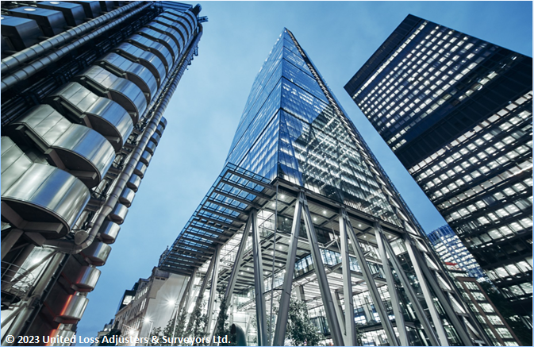

Document Control Page
Prepared by: | Reviewed by: | Approved by:
Estefani Haddad | Annie Abdel Massih | Petro Zaarour
Designation: | Designation: | Designation:
Claims Administrator | Claims Director | Director
Signature (Approver)
This survey and its issued report are without prejudice to the rights and or defences of the parties concerned.
Date of approval
30 January 2026

Version history | Date of issue | Reason for Revision
1 | 30 January 2026 | Issued – Final

The contents of this report are for the confidential information of the client.

Report Summary
At the request of Elite Insurance (the Applicant), ULA was requested to investigate a marine cargo claim (carried by sea and land) for M/s. Africa’s Best Choice Group Limited (the Consignee/Assignee) claiming by assignment on the policy of M/s. Concord International Group FZE-UAE (the Assured/ Shipper), to quantify the extent of damage/loss and report the claim on the subject policy when presented. Given that physical attendance at the time of loss was not possible, ULA’s scope of work was limited to reporting on the survey findings made available for this claim.
Table - Claim salient details
Assured’s Name | M/s. Concord International Group FZE-UAE
Broker/Agent Name | M/s. Elite Insurance
Insurer’s Name | M/s. Ion Insurance Group S. A.
Commodities | 1 x 40’ HC Container No. CAIU 8772002 STC 1,819 cartons of Led TV and Dry Battery.  Gross Weight: 24,670.00 KGS  Seal No.: SYA3448186
Arrival date at Consignee’s Warehouse | 09 January 2025 as per delivery note No. 31124 issued by M/s. Topmax Tanzania Limited.
- Container (No. CAIU 8772002) with 1,819 cartons of LED TVs and dry batteries was shipped from China on MV “XIN BIN HONG,” transhipped in Singapore via MV “MAERSK NADI,” discharged at Dar Es Salaam on 23 Dec 2024, and delivered to the consignee in Zambia on 09 Jan 2025 using M/s. Maruti Impex Limited for land transport.
- Upon discharge at Dar es Salaam Port, the container was inspected due to an initial weighing discrepancy, which was later confirmed to be immaterial to the subject claim. However, this prompted the local port authorities to unseal and reseal the container, during which signs of wet damage and dampness to the cargo were observed. The authorities did not inform cargo interests of this matter, thereby depriving them of the opportunity to minimise their losses and segregate the cargo into a new container.
- On 09 Jan 2025, the Consignee reported damaged cargo: wet LED TV cartons with rust, corrosion, and torn packaging; battery cartons were less affected. Water had pooled on the container floor and damaged cartons placed directly on the floor.
- The final assessment reported 300 cartons of batteries and 73 LED TVs damaged beyond repair, with water-soaking, crushing, deformation, rust, and corrosion observed. In view of the quantity of rainwater accumulated within the subject container, cargo damage likely occurred while at the port of transhipment of Singapore, during which it had been subjected to 9 days of tropical rainwater from two locations.
- The proximate cause of loss is water damage resulting from defective rubber door seals on the container during transit. The seals failed to maintain a weathertight condition, thereby allowing rainwater to infiltrate through the container. Based on the above and in view of the quantity of rainwater accumulated within the subject container, it is likely that cargo damage occurred while at the port of transhipment of Singapore, during which it had been subjected to 9 days of rainwater from two locations
In our opinion,
- The adjusted claim and policy indemnity presented by the Assured of USD 32,459.46 is fair & reasonable.
- The carrier, M/s. Cosco Shipping Lines Co., LTD should be liable for the subject loss, for failure to care for the cargo while in their custody.
- Given that physical attendance at the time of loss was not possible, ULA’s scope of work was limited to reporting on the survey findings made available for this claim. The claim recovery on the subject policy is left at the Insurer’s discretion.
- We confirm to have sighted the originals of all documents customarily submitted in support of a claim of this nature.
Contents
1. Appointment of ULA by the Applicants – Elite Insurance 5
2. Shipment Routing 6
3. Surveyor’s Notes 6
4. Notice of Claim 8
5. Quantum of loss 8
6. Past Weather Data Examination During Transit 8
7. Proximate Cause of Loss 9
8. Timing of the loss 9
9. Appointment of Assessors 9
10. Claim & Adjustment 9
11. Conclusion 10

Appointment of ULA by the Applicants – Elite Insurance
At the request of Elite Insurance (the Applicant), ULA was requested to investigate a marine cargo claim (carried by sea and land) for M/s. Africa’s Best Choice Group Limited (the Consignee/Assignee) claiming by assignment on the policy of M/s. Concord International Group FZE-UAE (the Assured/ Shipper), to quantify the extent of damage/loss and report findings of the subject, given that no physical attendance was possible at the time of unloading. Appendix A includes representative photographs and Table 1 is a detailed summary pertaining to this claim. The assignment of the policy between the parties was confirmed by the Applicant.
Table 1 - Claim salient details
Applicant  Broker/Agent Name | M/s. Elite Insurance
Insurer’s Name | M/s. Ion Insurance Group S. A.
Assured’s Name | M/s. Concord International Group FZE-UAE
Policy basis of cover and claim relevant warranties/conditions | Cover Note No.: MC/01/03/2024.  Insured Period: from 01 March 2024 till 01 March 2025.  Max Limit per shipment:  - USD 2,000,000.00 per vessel.  - USD 350,000.00 per Truck and/or Land Conveyance.  Basis of Valuation: FOB + 20%  Voyage: From: Anywhere in the world (China, India or East Asia, Europe, USA and America and African countries).  To: Insured’s warehouse in Kinshasa - Democratic Republic of Congo via Angola, Kenya, Congo, Tanzania, South Africa, Mozambique and Namibia.  Including shipments (containerized or non-containerized) for inland distribution to other consignees’ warehouses within the Democratic Republic of Congo, by land conveyance and/or by barge (whether self-propelled or towed) via Congo River.  Claim relevant basis of cover conditions:  - Institute Cargo Clauses "A" CL. 382 dated 01.01.2009.  - Institute English Jurisdiction Clause CL. 358 dated 01.11.1991.  - Loading and Unloading Clause.  - Institute Replacement Clause CL 161 of 1/1/34.  - Sue and Labour Clause.  - Duty and or Increased Value Clause  - Including Trans shipments  - Extra Expense Clause – USD 100,000.  - Excluding theft and wet perils from open /unattended trucks/ conveyances.  - Warranted carrying conveyance is clean and fit for the insured voyage and cargo is properly lashed, stored, positioned or secured for the intended transit.  - In the event of arrival of containers with broken or tampered seals, containers to be opened only under joint inspection and seals to be retained for Underwriters when required.  - Warranted secured printed seals or bullet seals with marks or numbers are placed on the containers during the whole voyage.  Deductible: USD 5,000.00 - per loss any one conveyance.
Terms of Sale | FOB as per commercial invoice No. ZCLGZ2024-006 issued by M/s. Concord International Group FZE dated 28.10.2024.
Shipper’s / Seller’s Name | M/s. Concord International Group FZE - UAE
Consignee’s Name / Notify Party | M/s. Africa’s Best Choice Group Limited, Kasumbalesa, Zambia
Bill of Lading No.  (Combined Transp.) | COSU6400357780 signed by M/s. Cosco Shipping Lines Co., LTD as agent for the carrier M/s. Cosco Shipping Lines Co., LTD dated 19 November 2024.  Shipper’s Load Stow Count and Seal.  CY/CY terms
Commodities | 1 x 40’ HC Container No. CAIU 8772002 STC 1,819 cartons of Led TV and Dry Battery.  Gross Weight: 24,670.00 KGS  Seal No.: SYA3448186
Port of Loading | Nansha, China
Port of Transhipment | Singapore
Port of Discharge | Dar Es Salam, Tanzania
Final Destination | Zambia, South Africa
Mother Vessel | MV “XIN BIN HONG” Voyage No.: 030S
Feeder Vessel | MV “MAERSK NADI” Voyage No.: 448W
Sea Voyage | Cargo loaded onboard MV “XIN BIN HONG”, Voyage No. 030S, on 19 November 2024 at Nansha, China, and discharged at Singapore on 24 November 2024. Thereafter, the cargo was trans-shipped and loaded on board the feeder vessel MV “MAERSK NADI”, Voyage No. 448W, on 03 December 2024, and finally discharged at Dar Es Salaam on 23 December 2024.
CMR No. | 6318 issued by Famari Investment (T) LTD
Lori/Trailer No.: | T824 DGP - T881 CHC
Driver’s Name | Mr. Geofrey Alphonce Mwangili
Land Voyage | Dar Es Salam -> Tunduma Borders -> Zambia (Consignee’s warehouse)
Arrival date at Consignee’s Warehouse | 09 January 2025 as per delivery note No. 31124 issued by M/s. Topmax Tanzania Limited.

Shipment Routing
The subject container was loaded onboard MV “XIN BIN HONG”, Voyage no. 030S as per Bill of Lading No. COSU6400357780. The container underwent transhipment in Singapore, transferred onboard feeder vessel MV “MAERSK NADI”, Voyage No. 448W. It was discharged at Dar Es Salaam on 23 December 2024 and later delivered to the Consignee’s premises on 09 January 2025, utilising the services of M/s. Maruti Impex Limited as the appointed land hauler (refer to enclosed Contract).

Surveyor’s Notes
- The shipment consisted of 1 x 40’ HC Container No. CAIU 8772002 STC 1,819 cartons of LED TVs and Dry Battery. The cargo was initially transported by sea from China to Dar es Salaam, Tanzania. Upon arrival at Dar es Salaam, the shipment was scheduled for onward transit by land from Dar es Salaam to Kasumbalesa, Zambia, to reach the consignee’s designated warehouse.
- On review of the pre-loading photographs provided as evidence (refer to Appendix A), the following were observed:
- The container exhibited signs of general wear and tear;
- Certain cartons were stowed directly on the container floor without palletization;
- Several cartons were loaded on wooden pallets and secured using PP straps and nylon stretch film;
- The pallets appeared to be in good condition and suitable for supporting the cargo;
- The cargo was stowed in straight rows, efficiently utilising the available container space.
- Upon discharge at Dar es Salaam Port, the container was inspected due to an initial weighing discrepancy, which was later confirmed to be immaterial to the subject claim. However, this prompted the local port authorities to unseal and reseal the container, during which signs of wet damage and dampness to the cargo were observed. The authorities did not inform cargo interests of this matter, thereby depriving them of the opportunity to minimise their losses and segregate the cargo into a new container.
- Following inspection, the original seal was reinstated on the container doors. The shipment was then loaded onto trailer No. T824 DGP - T881 CHC, driven by Mr. Geofrey Alphonce Mwangili, utilising the services of M/s. Maruti Impex Limited for onward land transport to the consignee’s warehouse in Zambia.
- An Equipment Interchange Receipt (EIR) was issued by M/s Jefag Logistics (T) Limited for Container No. CAIU 8772002, noting the following remark: “painted torn right side as received” (Copy enclosed). This remark however, was confirmed to only relate to paint and the container was not torn.
- On 09 January 2025, Delivery Order No. 31124 was issued by M/s Topmax Tanzania Limited, bearing a remark that Container No. CAIU 8772002 contained 300 cartons of batteries and 73 cartons of LED TVs, which were received in a damaged condition (Copy enclosed).
- While a notice of loss was issued to the carrier at the time of claim discovery, they elected not to attend. The Assured immediately discharged the cargo and had to arrange for the container’s inland return to avoid demurrage charges before ULA’s attendance. As such, evidence photographs were taken upon opening of the container and during unloading at the consignee’s premises for review (refer to Appendix B).
The following observations were made:
Upon opening the container doors:
- The cargo was observed to be fully loaded from floor to ceiling, with LED TV cartons and battery packages tightly stowed inside the container, leaving no visible void spaces;
- Upon removing several LED TV units from their outer packaging, which was found to be wet, the units were observed to be wrapped in transparent plastic; however, visible rust, corrosion, and brownish staining were evident on multiple casings beneath the plastic wrapping;
- LED TV cartons bearing the brand name “MAXIMA” were observed stacked in multiple tiers. Several cartons appeared torn, deformed, crushed, and structurally weakened;
- Battery cartons positioned near the container doors were observed to be dry, with no visible signs of wetness or staining at the time of door opening.
During unloading operations:
- Accumulation of water and wet patches were observed on the container floor, particularly toward the mid and front sections.
- Cartons stowed directly on the container floor, without pallets, were water-wet-soaked, with visible saturation and weakening of the carton material.
- Evidence of water migration upward as a result of inclination from the floor level was noted, as wet damage extended beyond the lowest layers of cartons.
- On completion of the unloading process, photographs of the cargo at the Consignee’s warehouse (refer to Appendix C), the following observations were made:
- Several LED TV cartons were found to be water-soaked, with visible wet staining, torn carton surfaces, deformation, and loss of structural integrity;
- Numerous LED TV cartons exhibited severe crushing and collapse, consistent with prolonged exposure to moisture;
- Rust and corrosion were clearly observed on exposed metal components of LED TVs;
- Palletized battery cartons were observed stacked; however, the cartons appeared softened, warped, and partially crushed, consistent with water saturation.
- A damage report dated 11 February 2025 was issued by Cargo Management & Logistics (Zambia) Ltd (copy enclosed) addressed to the Zambia Revenue Authority – Customs Services, Kitwe, reporting damage to part of Africa Best Choice Group’s shipment in Container No. CAIU 8772002. The report noted damage to 300 boxes of VINNIC R6 batteries out of 1,380 boxes received and 68 units of MAXIMA LED TVs out of 439 units received, attributed to rainwater ingress during transit. The matter was subsequently submitted to Customs for guidance on clearing the damaged goods.

Notice of Claim
The consignee, M/s. Africa’s Best Choice Group Limited issued a notice of Claim (copy enclosed) addressed to the carrier, M/s. Cosco, informing them about the damages, inviting them to a joint survey, and holding them liable. However, it should be noted that the carrier failed to attend.

Quantum of loss
Following final segregation, on-site units’ testing and evidence presented, the confirmed water-damaged cargo was deemed beyond repair and considered a total loss. Although no destruction certificate has been provided to date, we were able to confirm that the affected items are a total loss with no residual salvage/sale value. Insurers, at their discretion, may wish to request further information if necessary.
Below is the final detailed quantum of loss:
- 300 cartons of Pile Vinnic Crayon x 20pqt_112064.
- 55 cartons of LED Maxima 40" DVB-T2 X 1pcs_199670.
- 18 cartons of LED Maxima 55" Smart + Android X 1 Pcs_201724.

Past Weather Data Examination During Transit
The weather conditions during transit are summarised as follows:
- 19 November 2024: The container was at the loading port of Nansha, China; Light rain was recorded.
- 24 November 2024 to 03 December 2024: The container was at the port of transshipment in Singapore. Tropical 09 rainfall days were recorded on 24, 25,26,27,28 and 29 November 2024 and 01, 02 and 03 December 2024.
- 23 December 2024: The container was at the discharge port in Dar Es Salam: No rainfall was recorded.
- 23 December 2024 till 09 January 2025(arrival date at consignee premises): The Container was in land transit. No rainfall was recorded.

Proximate Cause of Loss
The proximate cause of loss is water damage resulting from defective rubber door seals on the container during transit. The seals failed to maintain a weathertight condition, thereby allowing rainwater to infiltrate through the container.
Based on the evidence made available, the deterioration of the seals was not externally visible, and the container exhibited no apparent gaps, misalignment, or deformation, rendering the defect undiscoverable upon reasonable inspection.
During the course of the investigation, it was confirmed that the Assured was not privy of the defect at the time of loading and that their site personnel did not observe any issues when conducting light‑test checks. Such water ingress would occur only under specific conditions, namely, sustained water exposure and pressure, rather than under the limited conditions of a standard light test.

Timing of the loss
Based on the above and in view of the quantity of rainwater accumulated within the subject container, it is likely that cargo damage occurred while at the port of transhipment of Singapore, during which it had been subjected to 9 days of rainwater from two locations:
- Door lower seal water infiltration: It is thought that the container was subjected to a level of cumulative rainwater higher than that of the container's lower door, due to a defective seal, through which it infiltrated. The majority of the affected items, which involved the first and second tiers of cargo stowed on the floor, were predominantly affected by the poor lower seal weathertightness.
- Door high right-hand seal infiltration: Items affected in higher tiers primarily involve LEDs, which have been wetted in their electrical connections area.

Appointment of Assessors
To date, it is understood that the Assured had not appointed a loss assessor to act on their behalf.

Claim & Adjustment
On receipt of invoice No. ZCLGZ2024-006 issued by the Seller M/s. Concord International Group FZE, dated 28 October 2024, the claimed and adjusted amount presented by the Assured is presented in Table 2 below:
Table 2 - Claim and Adjustment
Description | Damaged Quantity | Unit Price in USD  Adding freight & local Exp. ((19,000.00 + 609.55 +3,400.00 = USD 23,009.55/1,819 Cartons = USD 12.64/carton) | Total Claimed Amount
Pile Vinnic Crayon x 20pqt_112064 | 300 | USD 65.93 + USD 12.64 = USD 78.57 | 300 x USD 78.57 = USD 23,571.00
LED Maxima 40" DVB-T2 X 1pcs_199670 | 55 | USD 71.50 + USD 12.64 = USD 84.14 | 55 x USD 84.14 = USD 4,627.70
LED Maxima 55" Smart Android X 1 Pcs_201724 | 18 | USD 155.00 + USD 12.64 = USD 167.64 | 18 x USD 167.64 = USD 3,017.52
Adjusted Amount ------------------------------------------------------------------------------------------------------ USD 31,216.22
Uplift, 20% as per BoV ------------------------------------------------------------------------------------------------ USD 37,459.46
Less Deductible USD 5,000.00- per loss any one conveyance-------------------------------------------------USD 32,459.46
Say U.S. Dollars Thirty-Two Thousand Four Hundred Fifty-Nine & 46/100 Only.

Conclusion
In our opinion,
- The claimed policy indemnity presented by the Assured of USD 32,459.46 is fair & reasonable.
- On the basis of evidence, the carrier, M/s. Cosco Shipping Lines Co., LTD should be liable for the subject loss, for failure to care for the cargo while in their custody.
- Given that physical attendance at the time of loss was not possible, ULA’s scope of work was limited to reporting on the survey findings made available for this claim. The claim recovery on the subject policy is left at the Insurer’s discretion.
- We confirm to have sighted the originals of all documents customarily submitted in support of a claim of this nature.
End of report and adjustment note.

Enclosed Documents
- Signed Cover Note
- Original Bill of Lading
- Reverse BL
- CMR
- Commercial invoice
- Packing list-1477 1
- Detail Route of Shipment
- Delivery Note
- EIR Out
- Weigh Bridge Receipt - T824DGP
- Agreement For Clearance of Container
- Truck details
- Notice of claim to the carrier
- Driver details
- Damaged report
- Claim Bill

OUTSTANDING DOCUMENTS / REQUESTED, HOWEVER REMAIN UNAVAILABLE
- Proof of Payment
- Contract of Sale
- Destruction Certificate + Photos
- Loading photographs

References
[1]. Online accessed weather data by ULA online from the following providers for the relevant ports: https://www.timeanddate.com/weather/@1913164/historic?month=11&year=2024, https://world-weather.info/forecast/singapore/singapore/november-2024/,
and https://weather.com/weather/monthly/l/8aa93b35a7ababeae1d0ba872d9415766cad2fb0a9cad524aa0a75a08d05f2e4

[2]. Information supplied by the Assured and their agent between Feb 2025 and December 2025.

            - Pre-Loading Photographs
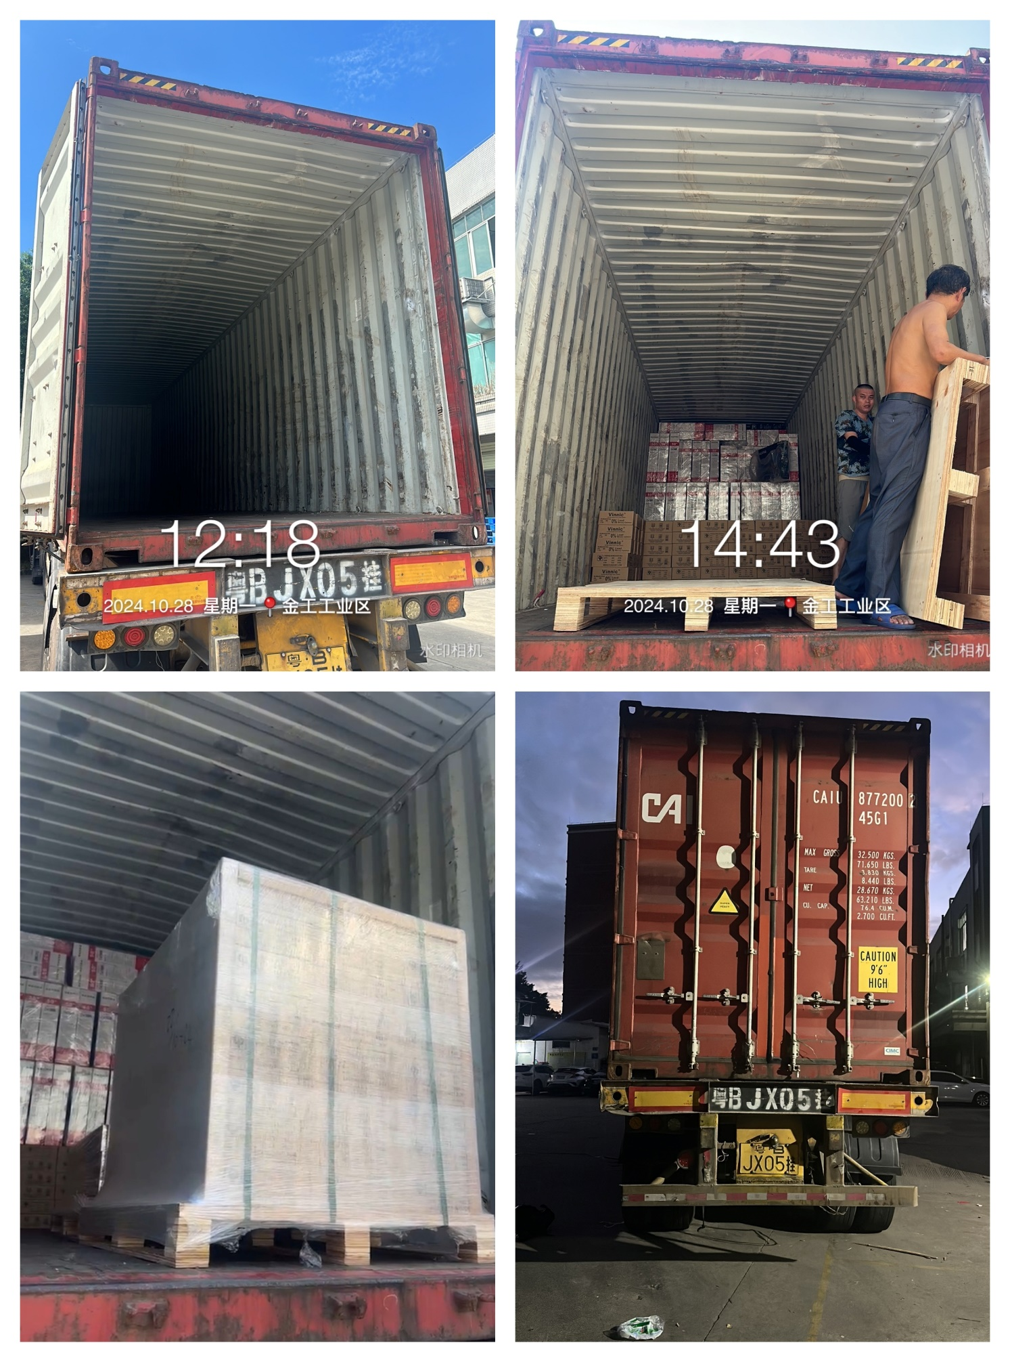
            - Representative photographs during unloading (additional available on request)
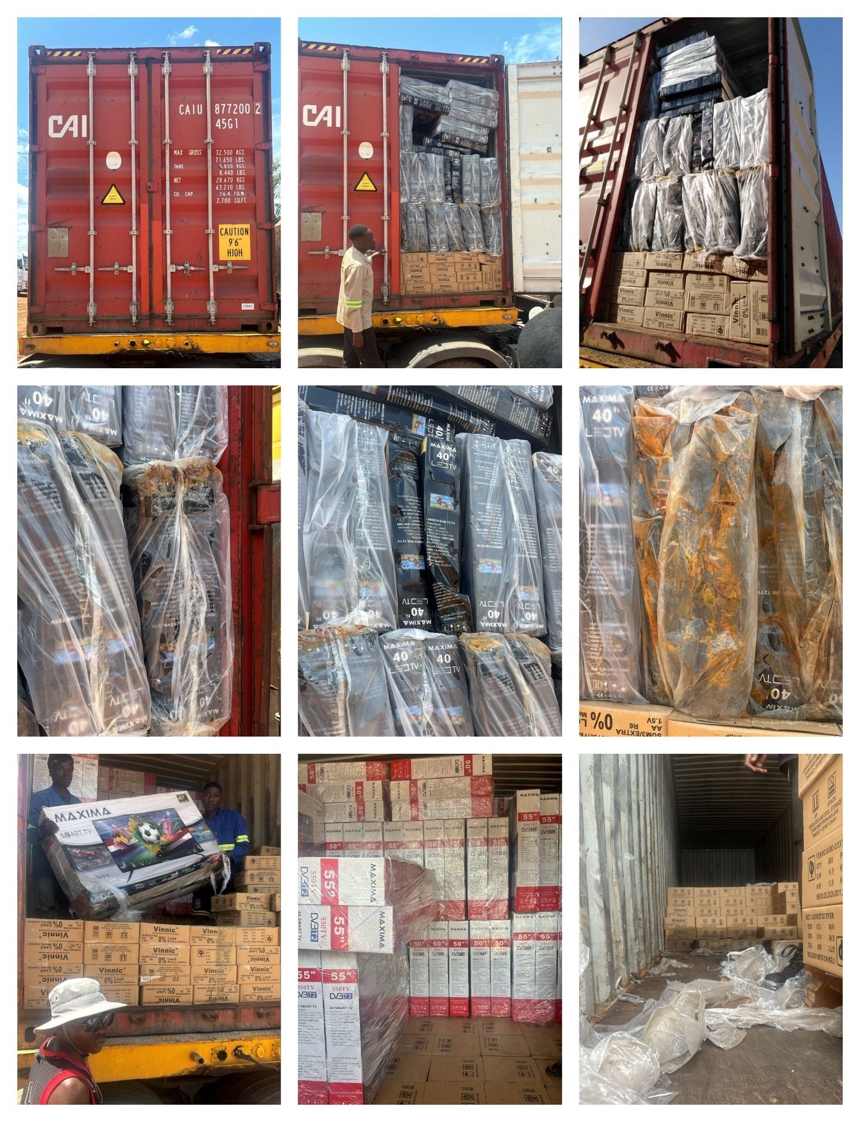
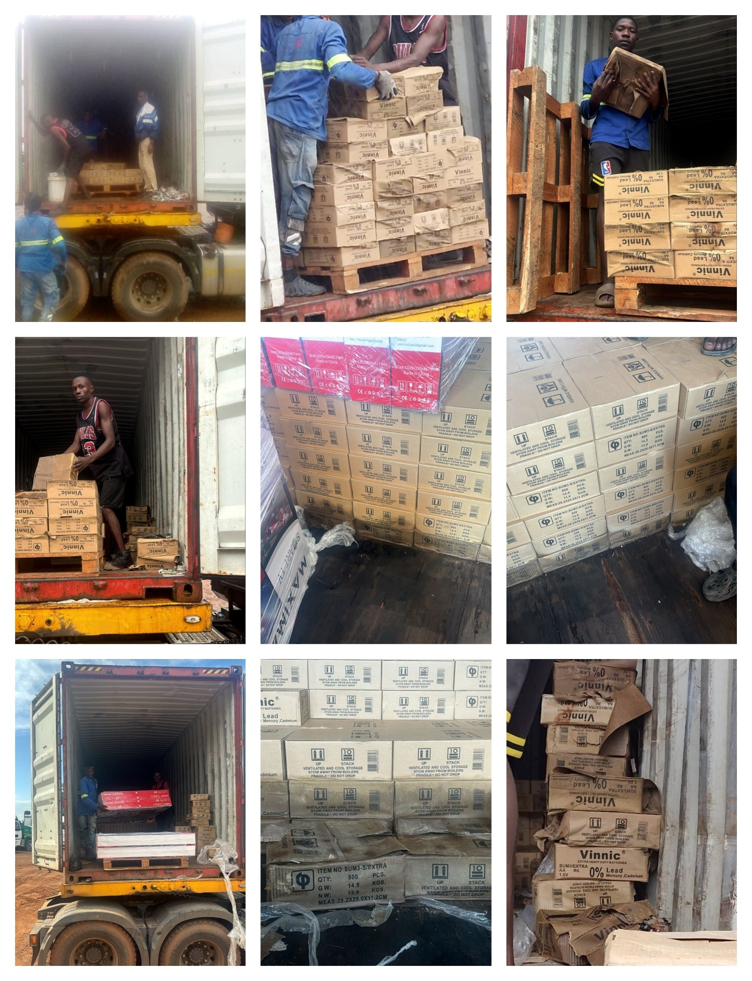
            - Representative photographs of damaged cargo
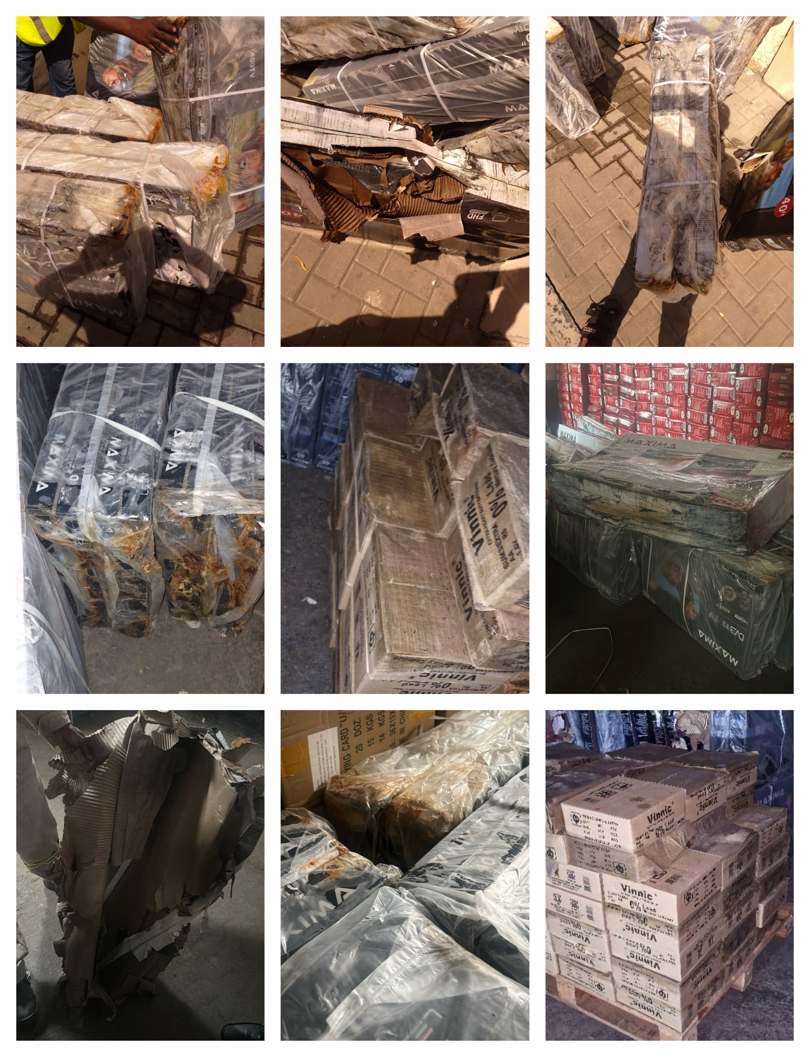
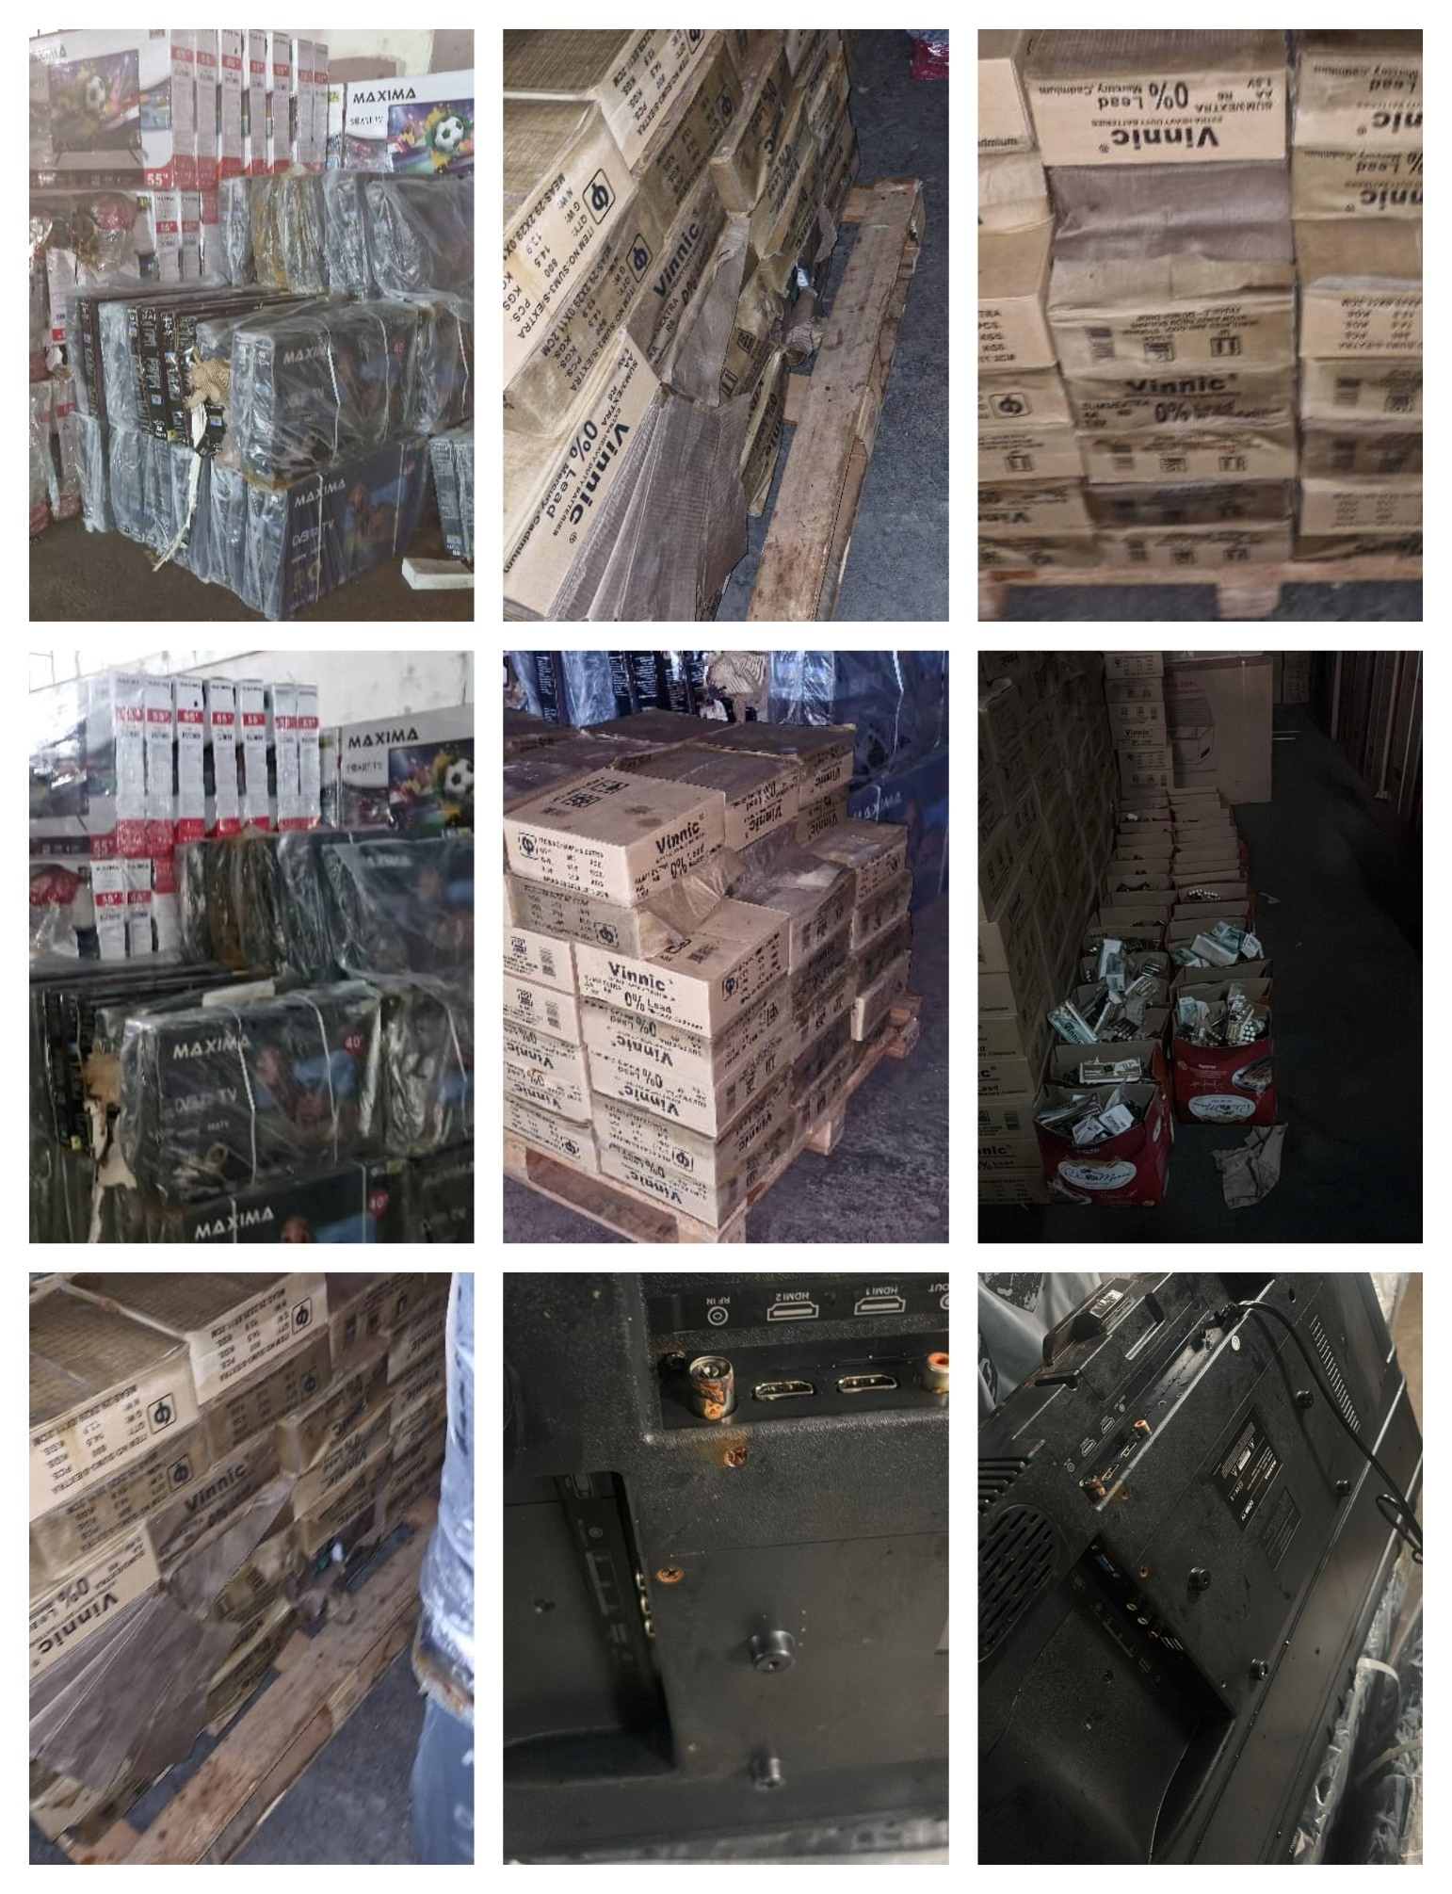
About ULA
United Loss Adjusters and Surveyors (ULA) is a leading international provider of Adjusters, Surveyors, Solicitors and Consultants, offering unrivalled technical and legal solutions with exclusive access to the London Market's leading specialists.
Established in 2002, ULA boasts strategic headquarters in both the Middle East and the United Kingdom. Today, it stands as the key partner of a premier legal firm ‘Clyde & Co.’ operating across 60+ countries and serves as the correspondent for numerous global technical service providers present in over 140 countries. Its clientele includes esteemed entities such as insurers, reinsurers, brokers, P&I clubs, ship owners, shipyards, H&M insurers, agencies, and various other stakeholders.
Lines of business:
- Insurance & Re-insurance
- Claims solutions and loss adjusting across all major lines: aviation, cargo, marine, property, fine arts, and special risks claims
- Cargo & Containers
- Marine & Offshore
- Global Claim Recoveries & Legal Support
Our team:
Our team comprises seasoned professionals proficient in Marine, Insurance, Finance, Engineering, and Law, renowned for their integrity and credibility. Backed by a dynamic, strategically located workforce, we swiftly address your queries with promptness and precision whenever and wherever our services are required. ULA maintains unwavering independence, ensuring unbiased perspectives uninfluenced by stakeholders, thereby earning your trust unequivocally.
ULA’s team members are recognised:
- Chartered Engineers
- Consultants
- Inspectors & Auditors
- Insurance & Re-Insurance Underwriters
- Loss & Average Adjusters
- Master Mariners & Chief Engineers
- Naval Architects, Marine & Offshore Engineers
- Solicitors
- Sworn Surveyors
ULA’s team members are also recognised members of the following international institutions:
- The Association of Average Adjusters (AAA)
- The Bar Council of England and Wales
- The Chartered Insurance Institute (CII)
- The Chartered Institute of Loss Adjusters (CILA)
- The European Federation of Loss Adjusting Experts (FUEDI)
- The Institute of Fire Engineers (IFE)
- The Institute of Marine Engineering, Science and Technology (IMarEST)
- The UK Engineering Council
- The Royal Institute of Naval Architects (RINA)
- The International Institute of Marine Surveying (IIMS)
- The Royal Institute of Chartered Surveyors (RICS)

Contact person
Annie Abdel Massih
Claims Director
United Kingdom: 71-75 Shelton Street, Covent Garden | London, England - WC2H 9JQ
Middle East: Mina Tower, Ain Waraka Street | Beirut, Lebanon - WG2G+5CX

Registered name United Loss Adjusters and Surveyors Ltd.

24/7 Contacts & Claim Support – T: +44 (0) 20 3287 3326 | M/WhatsApp: +44 (0) 7 375 110 573
Office E: claims@unitedlossadjusters.com
W: https://www.unitedlossadjusters.com/



